Be the BOSS of ADHD
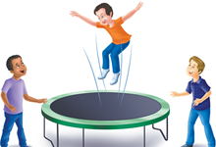
Exercise!
Impulse Control
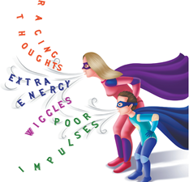
Superhero Breaths
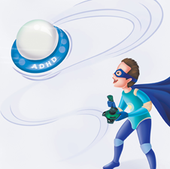
You are the BOSS of ADHD!

Be the BOSS of ADHD
Exercise
Impulse Control
Superhero Breaths
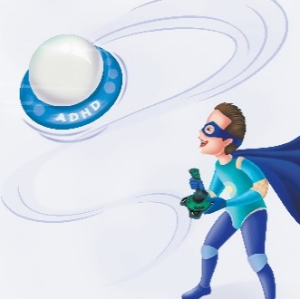
You are the BOSS of ADHD!

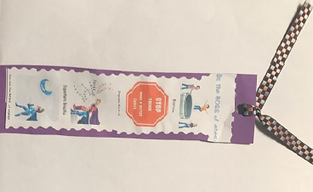
You can use this bookmark with your clients to helpthem remember how to be the boss of their ADHD! Best if printed on heavier paper and in color. I have also printed on regular copy paper and let the client glue to colored construction paper. You can buy lamination paper at any office supply store. Hole punch a hole on the top and add yarn or ribbon. Can be used as a book mark or door hanger. The illustrations come from my book, “My Warp Speed Mind.”

Thank you for downloading this bookmark.
Donalisa Helsley, LCSW
http://www.hopehealthharmonycounseling.com

