ABOUT ME CD COVER ACTIVITY
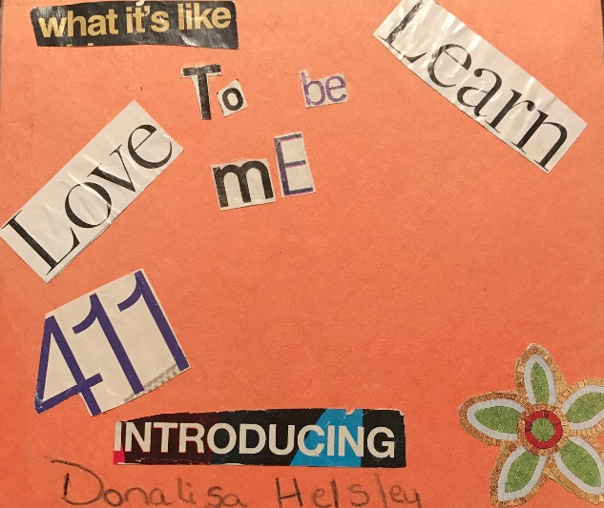
I love using this activity for new clients and groups. It helps loosen them up and build rapport. Also for reluctant to talk adolescents. I suggest the age to be 10+. I have had some younger clients complete.
Materials Needed:
CD Player, I Tunes< Pandora, Spotify (You get it. Something you can play music on. ) I ask them to pick a station or an artist they like to listen to.
Magazines
Construction Paper
Stickers
Glue
Scissors
Markers
Colored Pencils

Directions:
You can fold the construction paper in half and then half again until it is a square. I glue the inside to make both sides thicker. Then your clients choose whether they are drawing collaging etc. their cover. This is when I have the music on. We can chat quietly about the songs or I ask them to tell me what kind of pictures or what words or letters they are looking for and I help them cut things out of the magazine. I also make my own so I am not staring at them. During this time, I ask questions about their favorite food, colors, movies etcetera. Keeping it light. I document this activity as building rapport and identifying goals for the client.
Instructions to Client:
You are making a cd cover that describes you. On the front cover draw or cut out magazine letters or pictures to make the title. On the inside there will be a Side 1 (left) and Side 2 (right). Side 1 write or use magazine pictures, letters or words to make song titles that tell me about you/your life. Side 2 Make song titles that tell me what you want to be different about you or your life. Back cover decorate it however you want. I should be able to look at your CD cover and learn about you.
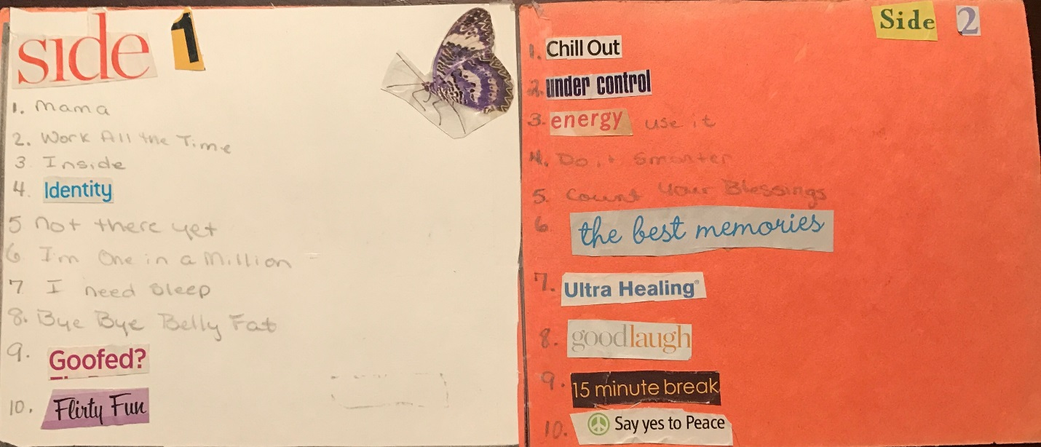
Finale:
At the end, depending on your client, some finish quickly, some take the whole time. I ask if they would like to talk to me about their song titles. If there is enough time left, I have them pick a title and write a verse to the song.
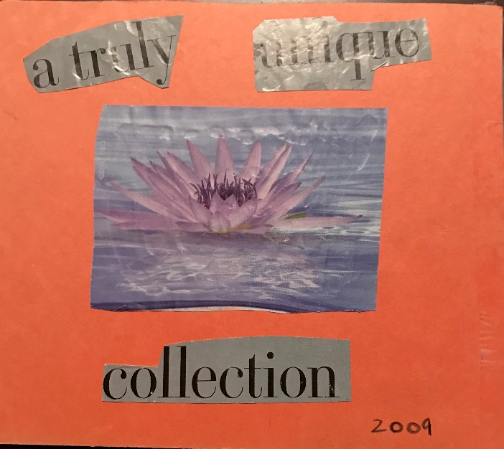
I hope you and your clients enjoy this activity.
P.S.
My clients usually want my CD Cover to take home with them and I let them. I only have the very first one I ever made to share with you. Don’t laugh. Next time I do this activity, I will show you how I have evolved since 2009.
😄 Donalisa Helsley, LCSW

