E | M | O |  | B | I | N | G | O

TO PLAY BINGO: Hand out BINGO card & playing chips, buttons, or pennies to cover their pictures. Call out a pattern from the list such as "Diagonal, Four Corners, or Cover All". Call out Emotions (ie: G- Angry) one by one. Players cover the emotion on their card with the chips. Pick one player that covered the picture to tell about a time they felt that way or make up a short story about why the character in the picture feels that way. The first person to cover all their pictures in the game pattern yells "BINGO!" and wins the game! Be sure to have a little prize for the winner or everyone.
For younger ages: For younger ages: Cut up the Bingo Words List and put the words into a bowl. Hand out BINGO card & playing chips, buttons, or pennies to cover their pictures. Call out a pattern from the list such as "Diagonal, Four Corners, or Cover All". Draw emotion word out of bowl and call it out ((ie: G- Angry) one by one. Everyone that has that emotion picture places chip on it. Players cover the emotion on their card with the chips. Pick one player that covered the picture to tell about a time they felt that way or make up a short story about why the character in the picture feels that way. The first person to cover all their pictures in the game pattern yells "BINGO!" and wins the game! Be sure to have a little prize for the winner or everyone.

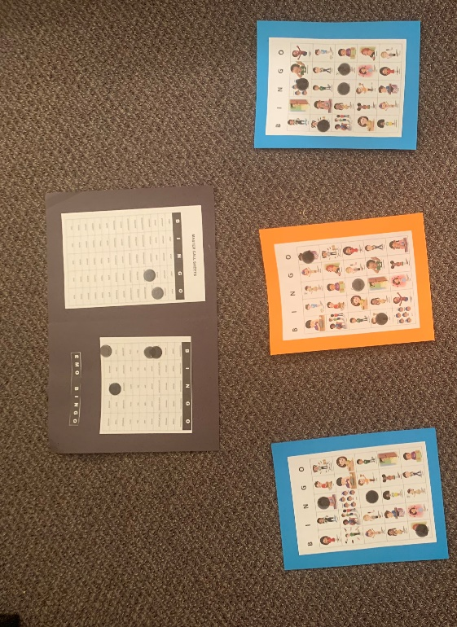

B I N G O

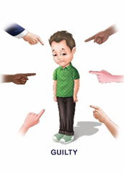 | 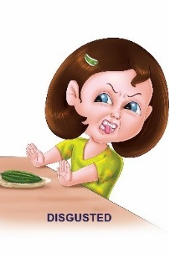 |  | 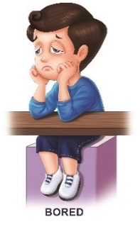 | 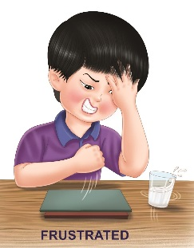
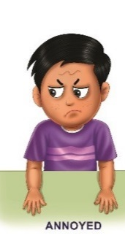 | 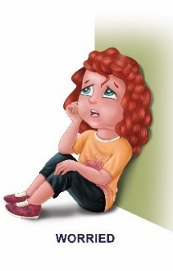 | 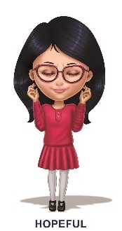 |  | 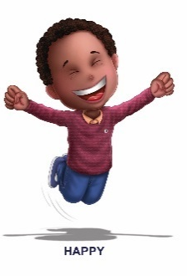
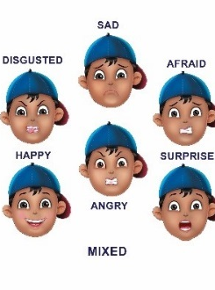 | 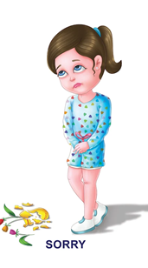 | Free  Space | 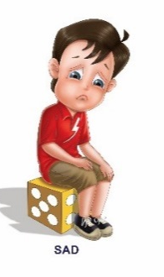
 |  |  | 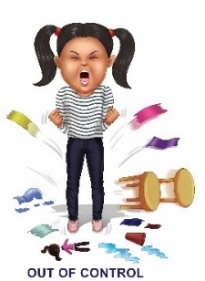
 |  | 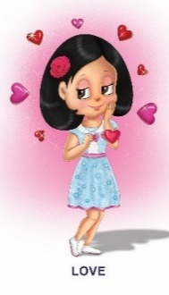 | 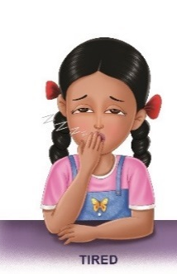 | 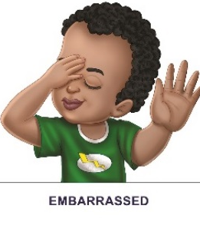

 |  |  |  | 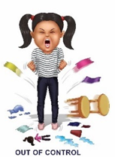
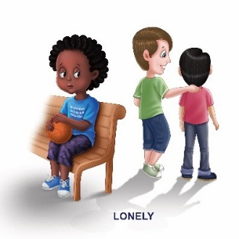 |  |  | 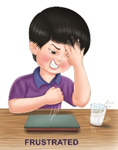 | 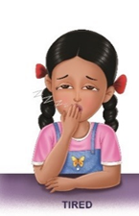
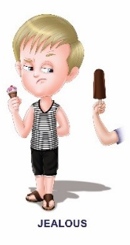 |  | Free  Space | 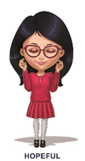 | 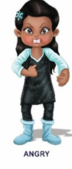
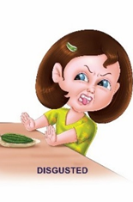 | 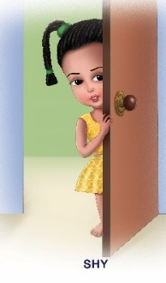 | 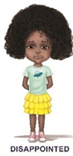 | 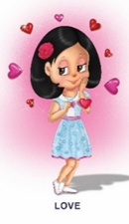
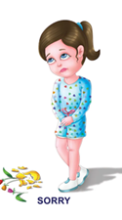 |  |  | 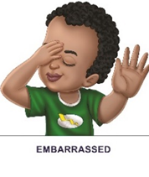 | 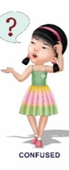
B I N G O

B I N G O

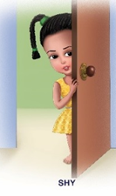

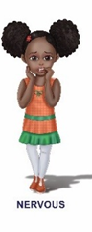
Free
Space
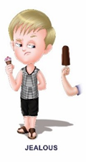 |  |  |  | 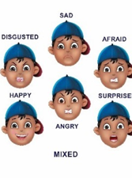
 |  |  |  | 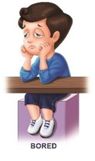
B I N G O

Free
Space
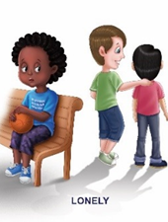

B I N G O

Free
Space
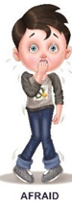

B I N G O

Free
Space

B I N G O

Free
Space

B I N G O

Free
Space

B I N G O

Free
Space

Free
Space
B I N G O

B | I | N | G | O
anger | anger | anger | anger | anger
annoyed | annoyed | annoyed | annoyed | annoyed
bored | bored | bored | bored | bored
confused | confused | confused | confused | confused
disappointed | disappointed | disappointed | disappointed | disappointed
disgusted | disgusted | disgusted | disgusted | disgusted
embarrassed | embarrassed | embarrassed | embarrassed | embarrassed
excited | excited | excited | excited | excited
frustrated | frustrated | frustrated | frustrated | frustrated
guilty | guilty | guilty | guilty | guilty
happy | happy | happy | happy | happy
hopeful | hopeful | hopeful | hopeful | hopeful
jealous | jealous | jealous | jealous | jealous
lonely | lonely | lonely | lonely | lonely
love | love | love | love | love
mischievous mischievous mischievous mischievous mischievous | mischievous mischievous mischievous mischievous mischievous | mischievous mischievous mischievous mischievous mischievous | mischievous mischievous mischievous mischievous mischievous | mischievous mischievous mischievous mischievous mischievous
mixed mixed mixed mixed mixed | mixed mixed mixed mixed mixed | mixed mixed mixed mixed mixed | mixed mixed mixed mixed mixed | mixed mixed mixed mixed mixed
nervous nervous nervous nervous nervous | nervous nervous nervous nervous nervous | nervous nervous nervous nervous nervous | nervous nervous nervous nervous nervous | nervous nervous nervous nervous nervous

B | I | N | G | O
out of control out of control out of control out of control out of control | out of control out of control out of control out of control out of control | out of control out of control out of control out of control out of control | out of control out of control out of control out of control out of control | out of control out of control out of control out of control out of control
proud proud proud proud proud | proud proud proud proud proud | proud proud proud proud proud | proud proud proud proud proud | proud proud proud proud proud
sad sad sad sad sad | sad sad sad sad sad | sad sad sad sad sad | sad sad sad sad sad | sad sad sad sad sad
shy shy shy shy shy | shy shy shy shy shy | shy shy shy shy shy | shy shy shy shy shy | shy shy shy shy shy
sorry sorry sorry sorry sorry | sorry sorry sorry sorry sorry | sorry sorry sorry sorry sorry | sorry sorry sorry sorry sorry | sorry sorry sorry sorry sorry
surprised surprised surprised surprised surprised | surprised surprised surprised surprised surprised | surprised surprised surprised surprised surprised | surprised surprised surprised surprised surprised | surprised surprised surprised surprised surprised
tired tired tired tired tired | tired tired tired tired tired | tired tired tired tired tired | tired tired tired tired tired | tired tired tired tired tired
worried worried worried worried worried | worried worried worried worried worried | worried worried worried worried worried | worried worried worried worried worried | worried worried worriedP worried worried

Anger | Jealous
Annoyed | Lonely
Bored | Love
Confused | Mischievous
Disappointed | Mixed
Disgusted | Nervous
Embarrassed | Out of Control
Excited | Proud
Frustrated | Sad
Guilty | Shy
Happy | Sorry
Hopeful | Surprised
Tired | Worried
E | M | O |  | B | I | N | G | O
Word List

Cut these Emotion words into strips and place in a bowl.

