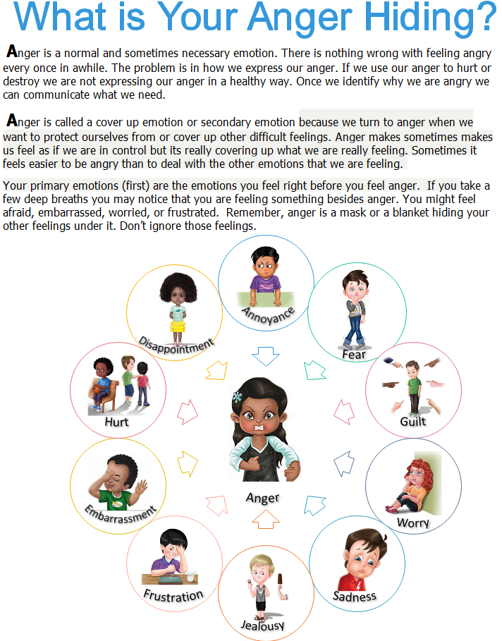

Identify Your Feelings

Sad | Scared | Ashamed | Hopeless | Tired | Disappointed
Anxious | Lonely | Guilty | Disgusted | Frustrated | Insecure
Bored | Hurt | Jealous | Depressed | Annoyed | Powerless
Unimportant | Shame | Overwhelmed | Bitter | Stressed | Rejected

Imagine the following situations. Ask yourself what primary emotion you might have in the situation in addition to anger. You may use the words above or any other emotion word that you believe you may feel.
- If someone makes a joke about my clothes in front of other people I would feel _____________.
- If my best friend told me that they didn’t want to hang out with me anymore I would feel_____________.
- If my parents promised to take me to a party but never showed up I would feel _____________.
- If my sibling broke my favorite toy I would feel_____________.
- If I’m having a hard time getting my homework done and my mom keeps giving me more things to do I would feel_____________.
- If I told my friend a secret and she told someone else I would feel _____________.
- If I loaned my friend a book and they gave it back ripped and stained with juice I would feel _____________.
- If I am trying to talk and no one is listening to me I would feel _____________.
- I always have to do what my friend wants to do. My friend never does what I want to do. I feel _____________.

Talk a time you acted out in anger but now that you take a moment you realize that you were feeling another feeling in addition to anger.

